**CS 7650 – Digital Image Processing**

Assignment 3 – Image Transformations for Data Augmentation

Kaitlyn Zahn

October 12, 2021

**Abstract**

This assignment’s purpose was to familiarize ourselves with image transformations using built in functions in OpenCV.

***PART 1***

Translate by (tx, ty) (10 points)

**Input Image**

**Output Images**

***PART 2***

Crop and Scale/Resize, upper left crop location and crop region size (15 points)

**Input Image**

**Output Images**

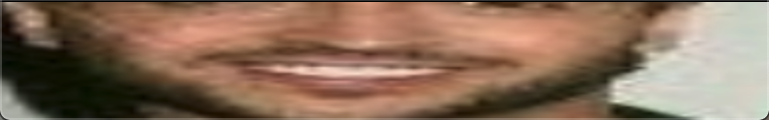

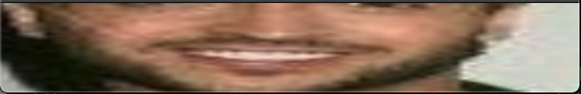

***PART 3***

Vertical-Flip about y-axis (10 points)

**Input Image**

**Output Images**

***PART 4***

Horizontal-Flip about x-axis (5 points)

**Input Image**

**Output Images**

***PART 5***

Rotate by five random angles between -180 deg to +180 deg (15 points)

**Input Image**

**Output Images**

***PART 6***

Randomly erase three (small) rectangular regions in the original image each at a different location and size (15 points)

**Input Image**

**Output Images**

***PART 7a***

Random intensity stretch for grayscale images (15 points)

**Input Image**

**Output Images**

***PART 7b***

Random contrast stretch one or more channels in RGB images (15 points)

**Input Image**

**Output Images**

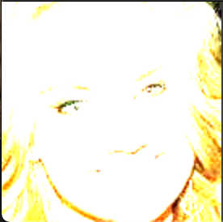

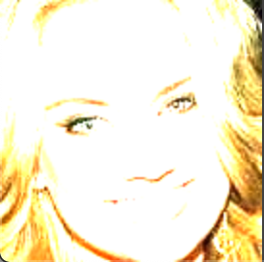

***PART 8***

Blurring using local averaging, use a box filter (all ones) of three sizes: 3x3, 5x5, 7x7 (15 points)

**Input Image**

**Output Images**

